Final Written Report

IST 440W Group 4

Alex Chin, John Wojtowicz and Phillip Berry

Table of Contents

Overview 3

Purpose and Overview of the Project 3

Background to the proposed work 3

Planning and Design 5

Objectives 5

Scope 6

Benefits 7

Assumptions 8

Constraints 9

Risks 10

Other areas of Project affected 12

Logical Testing 12

CASE ONE 13

CASE TWO 14

Backend Unit Testing 16

Frontend Unit Testing 17

Other Crash Avoidances 17

Results, Conclusions and Future Work 18

Changes in development 18

Challenges 19

Lessons learned 20

Future Work 20

Mobile-friendly application 21

Optimization & improvement of certain UI elements 21

Real-world testing 22

Scalability and Stability 22

# Overview

## Purpose and Overview of the Project

As a group we have recognized a business need for a secure and efficient file sharing system that maintains a high level of security and easy remote access. With all major modern businesses now taking advantage of ERP (Enterprise Resource Planning) software we decided that integrating our project into the ERP environment only made sense. In addition, we would be able to leverage the interconnectivity that makes ERP software so attractive into our project to make it more robust and feature rich.

## Background to the proposed work

This project began as a proposed idea from Alex Chin to create some sort of central repository for documents within a company that would serve to better ensure that everyone maintained and worked from the latest version of any document. This would in turn help to negate or minimize any loss in productivity due to versioning confusion. This could regularly occur when two individuals make edits to different versions of the same document and then when merged, combined, or checked in would result in the loss or invalidation of one or both individuals’ work.

Having some experience in ERP environments and with other file repository software, such as Box, iManage and shared folder locations, Phillip Berry suggested that the group leverage the Roles and Permission levels that are already built into ERP environments in order to facilitate access and security of the file storage environment. In addition, using ERP helped to leverage the built-in philosophy or ERP environments of having everything in one central location with all necessary interconnectivity to keep all departments. This could also help to overcome the limitations of applications such as iManage and Windows Shared Folders system where each and every folder has to be updated with possibly unique permissions to ensure only certain individuals or groups have access to them. iManage also suffers from the limitation of having to “check out” documents which means that you lose the ability to real time edit and collaborate within one centralized version of a document. Windows does help to overcome this however in that the Office Suite of software allows for multiple people to edit a document in real time.

# Planning and Design

## Objectives

Our objectives for this project are ambitious in scope to say the least. This type of software can become massive, and the scope of features can continue to grow and endanger a project schedule with “feature creep”. Our groups major goals and objectives for this software is to provide robust and easily editable security and permissions, the integration of cloud storage, simultaneous an a-synchronous collaborative capability, easy and efficient sorting capabilities, version and change log tracking, document metadata database to facilitate sorting and mobile access and viewing capabilities.

Thankfully some of these proposed features either work hand in hand or are required for each to work. Some examples of these include, leveraging cloud storage will in turn allow for easier remote access to files and mobile device viewing. Another would be the creation of a database of metadata, such as creator, editor list, creation date, creator’s department and so on will help allow for more ways to facilitate advance sorting capabilities. Even with these dependencies in technologies and interwoven capabilities we are under now illusion that this project is a grand “pie in the sky” project. Our feeling about this though is that it is exactly these projects that aim to far surpass normal conventions are the ones that exceed the competition even if they fall a bit short of their goals.

## [Scope](https://www.stakeholdermap.com/project-dictionary/project-dictionary-s.html#scope)

As mentioned previously this is a project that can be very susceptible to feature creep. As such it is a good idea that we as a group set up a strict scope of work and enable hard boundaries on what we would like to accomplish for the release of this project. Should a feature come along that everyone agrees should be in this project its implementation will be limited exclusively for ensuring that the released project is set up for its future implementation. In other words, there is to be no work done on the proposed feature before the release of the project but any foundational work that would be needed to implement the feature in the future should be done now so that future development is not hindered by the fact that the released version cannot support the feature.

The features for the project as they stand now is the creation of an ERP interface that will link third party software, such as Microsoft Word with files that are to be housed in a cloud storage location to allow for the editing of these files. The interface which is the primary body of the project will support ERP permission groups to restrict user file access, easy and robust sorting and filtering. Remote access via mobile devices allowing for browser viewing only and collaborative document editing. These features allow for the creation of a strong competitor in this market. Once created this ERP software can be sold and implemented in the ERP software, of the same manufacturer, for any company. This means that this software, if created in Oracle NetSuite will not be able to be installed into Deltek Vision at launch. This cross compatibility may be something that can be done in future releases.

## Benefits

For this project we expect the benefits from the secure and feature rich file sharing functionality of our product will be both tangible and intangible. The tangible benefits for Tech 440 Enterprises will be the creation of a industry standard file sharing software that will not only get our foot into this ERP market that is currently showing amazing growth, but also the creation and building of a client base that will become more and more invested in the products that we will create after this one. We will accomplish this growing customer base by providing a product that our customers will immediately recognize as being a tool that will securely and safely improve the work efficiency of their employees and improve the communication within their company.

The primary target of beneficiaries will be the direct employees of our customer companies that purchase our product. This will further extend to include the management group of the company that purchases our product when they see the efficiency increase of their employees provided by the use of our product. For example, the ability to establish seamless communication of data and documents will allow the users to reduce extra time and effort spent on data validation. This will be accomplished by providing a system of managing a central repository of data files and allowing for the update of these files or new file that are created or uploaded to the system. These files will instantly become available through cloud, or local storage to the user and any other users with the appropriate permission. Employees will no longer have to worry about the state or the integrity of the files that are hosted.

In this way Our company and products will benefit from forming a symbiotic and mutual relationship between ourselves, the ERP environment manufacturer and the customer companies. The ERP environment manufacturers will benefit from the added value our applications will provide to their environments functionality and the Customer company will see added efficiency provided to their employee’s workflow. We will, of course, benefit from this monetarily through the purchase of our product.

## Assumptions

This project will be created using the tools and resources that are free to Penn State students such as Microsoft Office and Adobe XD. It can be assumed that the subscription-based programs remain in effect during the duration of the project. With that being said, the required funding of the project is already paid for by the University. Additional funding may be needed to implement the project into an ERP system once created, although that may be paid for by the company. Assuming the project has been implemented into the company, employees must be trained on how to use the software.

For the purpose of this project, we are working under the assumption that the market will not change and there will remain a need for our product. In addition to this we have to assume that there is a desire for our product and that customers will be willing to trust an unknown company to provide software for the single software suite that can determine their success as a company.

We must also assume that our customers are experience in the field of ERP and understand that there will be some growing pains during development and installation. As Dawn Aldwinckle points out in her article “4 Costly Assumptions That Lead Businesses to the Wrong ERP Solution” from the ERP Focus website, customers always assume that there will be a seamless and easy integration of a product into their ERP suite.

## Constraints

The largest business constraint that we will have to work within is the previously mentioned competition within this segment. The larger companies have the option of building a product similar to us after its release and then pricing us out of the market in order to remove us as their competition. In order to combat this, we will have to consistently update and improve our product to stay as good as or better than them for what we do. It will also be beneficial if we could find our niche within the segment. In other words, we must remain vigilant on what products we can release that are not already provided by the larger companies without stepping on their toes and upsetting them.

With the implementation of the file sharing application, there are some constraints that we must work around to ensure that the project is completed successfully. Arguably our biggest constraint would be the tight schedule to complete the project in and the restrictions in manpower we face. The August 10th deadline leaves us roughly two and a half months to complete the project. As we are restricted to three team members, completing the project in this timeframe may prove to be more difficult than would normally be the case. Once implemented, the company must train their employees how to utilize and operate the application, which will cost more money. This is necessary however as we will need to support the product once it is released to our customers. Since security is of such high concern for both us and our potential customers, we will need to hire a security analyst to monitor the latest standards and threats to data traffic and ensure no errors occur and no data breaches can occur.

Unlike an established company we will also have to build ourselves from the ground up. To do this we need to find and secure financing through investors to gain the capital that we will need as a fledgling company. As we gain investments, we need to continue to look forward on how we expand next. During the latter half of this projects development cycle we will need to start building and educating support staff for our customers. We cannot just release a piece of software to customers and end our relationship there. There will always be the next thing that we will need to build ourselves toward before it is needed.

## Risks

Our primary risk currently is being able to secure funding and deliver a viable product to market on time and on budget. This is vitally important for us since we are a fledgling company that needs to have at least one product in the market to help build a name for us and our work and to help keep a incoming cash flow so that we can continue to expand and provide more products in the future. In addition to this we must accomplish this while on a tight schedule and with limited employee resources. This is a common risk for all new companies and is the first testing ground that a company must pass through in order to earn the chance to grow.

Once we have made it through this first hurdle out biggest risk will be defending ourselves from our competition. This competition will come in two types the first being a direct product competition, or another company that releases a product similar to ours and steals market share from us, thus stifling our growth. The second type of threat that we may have to face is the threat of either being priced out of the market by a larger more well established company who has the product line up in their catalog to allow them to take a short term loss on a product similar to ours in order to remove us from the field, or to simply purchase us and our product and strip our company down for parts.

As of right now these are our two primary hurdles we must face. Once we have proven that we can weather these threats we can re-evaluate our surroundings and start identifying other strategic risks to our company and the portion of the business segment that we wish to operate within.

## Other areas of Project affected

During the process of creating this software we must also remain vigilant and aware of the current and ever-changing business landscape that we intend to occupy. This includes maintaining the best possible security within this project and adhere to the current state of best practices for data security and management. Part of how we will accomplish this is by allowing the customer to chose how they wish to store their data. Do they find the benefits of cloud storage and anywhere on the go access to this data more appealing than maintaining a local storage of files that they can control?

Next, we will have to not only train our support staff but the customer on how to implement and maintain this product in their company’s chosen environment. Our responsibilities do not end at the point of sales. If we wish to grow the value of our name, then we will have to not only provide a quality product but maintain a award winning support service to address any concerns that our customers may have. If we fail to do this, then word of our failings will quickly spread throughout the industry. This support staff will also be leveraged in order to train the on-site customer resources on how to use the product. Any work we can do to be proactive and provide the answers to the company or someone within it so that they do not have to approach us with it will help ease burdens on them and us which will be a cost savings for both of us.

## Logical Testing

## CASE ONE

Case one involves a user accessing the file sharing application within the ERP and viewing a file shared to them. If the user were to select a file that was shared to them, but the sender revoked access, then the application would crash as there is no file to be retrieved. Files can be sent mistakenly to the wrong person or access must be denied for security reasons, leaving the end user with no option to return to the main page of the ERP once the file is clicked. *Figure 1* displays the necessary code changes that were made to ensure the user will receive a pop-up asking to verify from the sender.

Text Box

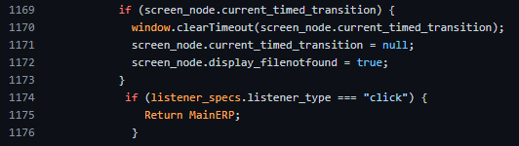

Necessary changes were made with the UI to display a warning message to the user as shown in *Figure 2*. The user can see the file could not be retrieved and contact the sender if needed. Clicking the file will allow the user to return to the main page of the ERP or access other files in the file sharing application without crashing.

Text Box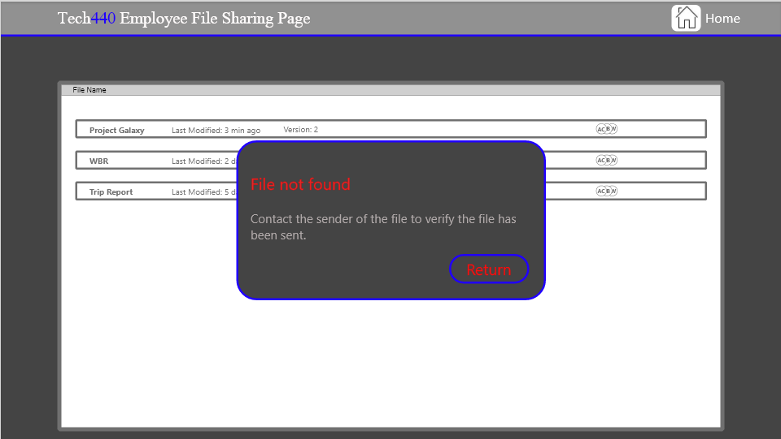

## CASE TWO

Case two involves a situation when the user may need to open two files at once to complete a project. Currently, selecting more than one application will crash the file sharing application as that is not supported. We feel it will be necessary for users to be able to access more than one file shared with them at a time. Employees of the organization will commonly find themselves working on projects that correlate with others, which is why adding a way for users to access more than one file is so important. *Figure 3* displays the necessary code changes that allow the application to pull multiple files from the centralized cloud server.

Text Box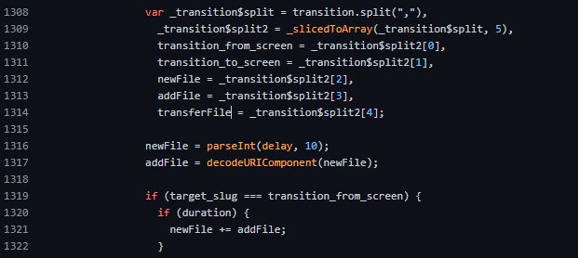

The UI now displays multiple documents selected from the file sharing application. These documents can be edited simultaneously, as the changes will be saved in real-time and send back to the server. As shown in *Figure 4*, the user will be able to view the documents simultaneously.

Text Box

## Backend Unit Testing

The backend unit testing ensures that our current code can communicate with the centralized cloud server where the data is stored. Employee information regarding the file sharing application is stored on a centralized cloud server within the ERP and the file sharing application must be able to communicate back and forth for push or pull requests.

Since the file sharing application is embedded in the ERP system, employee communication between each other is already established. The file transfers are simply stored on the central cloud server and available to users who have access. Any edits to the file will be automatically sent to the server to be viewed on other shared user’s computers. Since our code is mainly CSS, we were able to test this by viewing the file stored on the server in the form of a URL as shown in *Figure 5.*

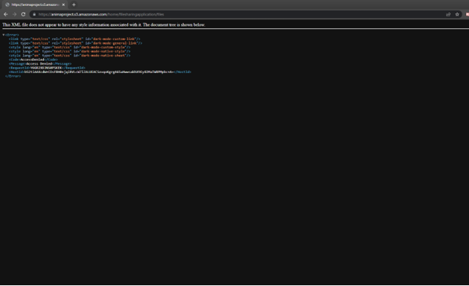Text Box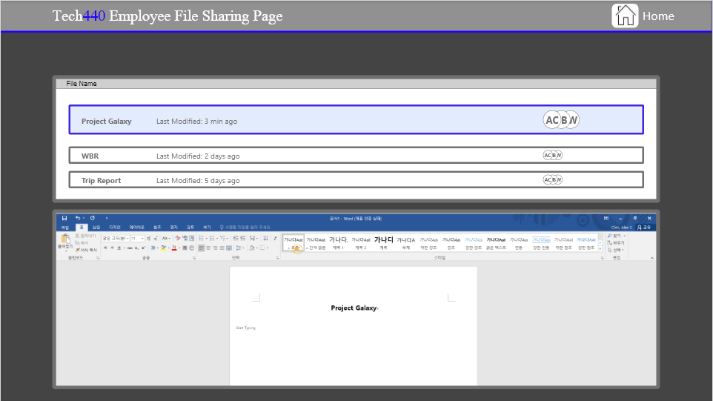

## Frontend Unit Testing

During the development, we noticed there were dead ends when using the file sharing application and trying to return to the ERP system. Depending on what the user clicks, the file sharing application will always return to the main page of the ERP system. We replaced different instances with pop-up notifications allowing the user to navigate easier within the file sharing application.

If a user is unable to access a file or is having trouble with the application, they will be able to return to the home screen and contact any employee who may be able to fix the issue. The user will now be able to contact the sender of the file without experiencing any issues while returning to the ERP system.

## Other Crash Avoidances

Since the file sharing application relies heavily on the centralized cloud server, it is important that the server has proper maintenance and security. To limit future problems, users should contact the sender to ensure everything is in check on their end. The central cloud server must be stable for users to send and receive files, and the activity must be monitored closely.

# Results, Conclusions and Future Work

## Changes in development

Our development process remained the same throughout the project with the end goal of creating a file sharing application within an organization's ERP system. During the project, it was decided that a centralized database would be more efficient in terms of storing the information used for the file sharing application. Users would then be able to pull files from the centralized database and information would be more secure. If future problems were to arise, all the information would be centralized, making it easier to solve the problem. Due to the short time frame to complete the project, the team decided to outsource the code to complete the project in time. The application was coded to communicate strictly with the centralized database, as all information between users will be stored in that location. Eventually, the team decided to implement code to enable users to open more than one file at a time to offer extra layers of collaboration within the organization. Since most projects will include multiple files, the team decided on an additional implementation to increase usability. Once the project is deployed to an organization’s ERP system, the organization can modify the application to accommodate specific needs. Due to time constraints, the UI is not as appealing as the team intended but future changes can be made by outside vendors to improve the appearance of the UI.

## Challenges

After deciding on the subject matter for our project the primary goal was to complete as much of the project as we could as fast as we could. This was necessary due to the shorter schedule for the summer semester. Due to this challenge much of the progress that was made on this project was made as we learned the tools that we were working with. This shortened timetable added a lot of pressure to the team in the early days of the project. We had more work to complete than we had time to reasonably accomplish it.

Soon after the project started it became apparent that we needed to figure out a way to insert a shell that could support the use of Word or other Microsoft Office applications within a website page. After mush research and study by Alex it was determined that we would need to use an Adobe XD add-in called Anima. The downside is that this add-in was needed for anything we produced to work properly. So, if we exported the code to the site and gave it to someone else then it would not work correctly unless they had the add-in installed as well.

Lastly it has become apparent that due to the sheer scope of this project there is always more that should be done to it. This unfortunately leaves us with the feeling that the project appears half completed or lacking in features. While what we have is perfectly functional and accomplishes the goal of the project it always could more features and be more polished.

## Lessons learned

If we were to do this project over again, we would likely be better served to take better stock of what are strengths are when it comes to the tools, we would need to use to complete the project and then create a new project that would use these tools and make sure to keep it on a tighter scope. We feel that the project would be more satisfying and impressive if it were more polished and complete but smaller in design. Doing it this way could help us to provide a product that would be much more impressive. This would also allow us to put more thought into what tools would be needed to accomplish the project.

Secondly, we would have been better served to better define the responsibilities of the group members and keep the milestones on a tighter schedule. By doing this there would be less confusion as to who was responsible for what or would complete which tasks and we could be sure that all deliverables were completed and placed in their assignment folders earlier to make for a smoother submission of products to Canvas.

Along this same thought it would be better for a detailed survey on what the skills of the possible group members would to a group would be to help ensure that your group contains the skills that would be necessary to accomplish this project. This would in turn help define those roles and ensure that each group had the tools that they needed to complete their project.

## Future Work

What remains to be further developed in the future can be divided into two different categories: technical, and user experience Although Tech440 was able to produce a working program that can be implemented into existing ERP systems, the program is not fully stable. It was programmed through a third-party software, Adobe XD, in which the codes are not optimized for diverse and scalable use. Thus, Tech440 plans on either hiring backend developers or working with a vendor to add stability and scalability into the program.

Also, as a newly developed program, our product lacks user feedback. As Tech440 recognizes the importance of customer obsession, we plan on enabling free access to our program for the first three months of the launch in replacement of a beta-test run. User feedback will then be gathered to determine the areas of strengths and weaknesses. Furthermore, as Tech440 currently lacks human resources in both fronted and backend development, the current User Interface of the product does not raise the bar in the market. Thus, front-end developers will be hired along with the backend developers to provide more user-friendly program.

## Mobile-friendly application

Tech 440 is intended to work within the ERP system of an organization. If the organization provides mobile support through their ERP system, then future implementations can be made to accommodate. Due to time constraints and most ERP systems functioning on a desktop, there currently is no mobile support for the file sharing application. Adding mobile support can be an option for organizations who wish to have both desktop and mobile versions of their ERP systems.

## Optimization & improvement of certain UI elements

The User interface of the file sharing application contains many of the aspects we intended for, however the design and layout can be improved. If future implementations were to take place, the team agreed to hire a UI designer to make the application more appealing for users. The UI can be changed specifically to adhere to the organization’s ERP systems and contain color schemes to match with the organization. Certain UI elements can be added upon request from the organization to better fit the company and add all components necessary to make file sharing as convenient as possible.

## Real-world testing

As previously mentioned, Tech440 currently lacks data in real-world user feedback. In order to gain direct feedback from as many users as possible, Tech440 plans on providing free access to the program for three months after the initial launch. This time period will be utilized to assess strengths and weaknesses of our program from the users’ perspectives. Collected feedback data will then be passed onto the frontend and backend developers for further development.

## Scalability and Stability

Currently, Tech440 relies on a third-party program to host the server, Anima. However, the stability and scalability of this server have been raising concerns. Thus, Tech440 plans on cooperating with a bigger vendor that can provide more reliable web services. Although further research and decision makings are still required, Amazon Web Services seems to be the best fit so far. Due to AWS’s ‘pay as you go’ pricing policy, Tech440 will be able to reduce the cost while solving the scalability and stability problems. If our program safes sudden increase in the traffic, Tech440 can simply order more servers to be hosted. On the other hand, less servers can stay open during the time of lower traffic.